onmouseover Event :

Definition and Usage

The onmouseover event occurs when the mouse pointer is moved onto an element, or onto one of its children.

Tip: This event is often used together with the onmouseout event, which occurs when a user moves the mouse pointer out of an element.

Syntax

In HTML:

<element onmouseover="myScript">

In JavaScript:

object.onmouseover = function(){myScript};

In JavaScript, using the addEventListener() method:

object.addEventListener("mouseover", myScript);

Program

<!DOCTYPE html>

<html>

<head>

<style>

div {

width: 100px;

height: 100px;

border: 1px solid black;

margin: 10px;

float: left;

padding: 30px;

text-align: center;

background-color: lightgray;

}

p {

background-color: white;

}

</style>

</head>

<body>

<h3>This example demonstrates the onmouseover.</h3>

<p>The onmouseover event occurs when the mouse pointer enters the div element, and its child elements (p and span).</p>

<div onmouseover="myOverFunction()">

<p>onmouseover: <br> <span id="demo3">Mouse over me!</span></p>

</div>

<script>

var y = 0;

function myOverFunction() {

document.getElementById("demo3").innerHTML = y+=1;

}

</script>

</body>

</html>

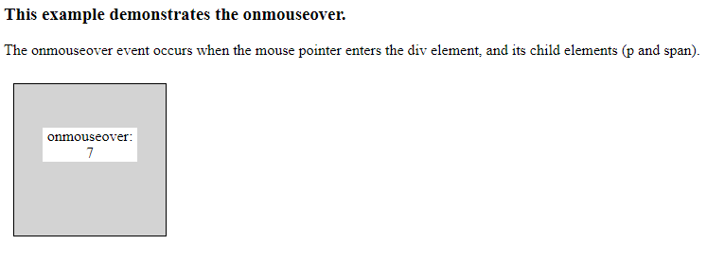

onmousemove Event

Definition and Usage

The onmousemove event occurs when the pointer is moving while it is over an element.

Syntax

In HTML:

<element onmousemove="myScript">

In JavaScript:

object.onmousemove = function(){myScript};

In JavaScript, using the addEventListener() method:

object.addEventListener("mousemove", myScript);

Program:

<!DOCTYPE html>

<html>

<head>

<style>

div {

width: 100px;

height: 100px;

border: 1px solid black;

margin: 10px;

float: left;

padding: 30px;

text-align: center;

background-color: lightgray;

}

p {

background-color: white;

}

</style>

</head>

<body>

<h3>This example demonstrates the difference between onmousemove</h3>

<p>The onmousemove event occurs every time the mouse pointer is moved over the div element.</p>

<div onmousemove="myMoveFunction()">

<p>onmousemove: <br> <span id="demo">Mouse over me!</span></p>

</div>

<script>

var z = 0;

function myMoveFunction() {

document.getElementById("demo").innerHTML = z+=1;

}

</script>

</body>

</html>

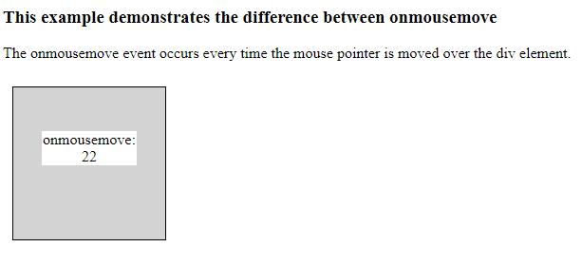

onmouseout Event

Definition and Usage

The onmouseout event occurs when the mouse pointer is moved out of an element, or out of one of its children.

Tip: This event is often used together with the onmouseover event, which occurs when the pointer is moved onto an element, or onto one of its children.

Syntax

In HTML:

<element onmouseout="myScript">

In JavaScript:

object.onmouseout = function(){myScript};

In JavaScript, using the addEventListener() method:

object.addEventListener("mouseout", myScript);

Program:

<!DOCTYPE html>

<html>

<head>

<style>

div {

width: 100px;

height: 100px;

border: 1px solid black;

margin: 10px;

float: left;

padding: 30px;

text-align: center;

background-color: lightgray;

}

p {

background-color: white;

}

</style>

</head>

<body>

<h3>This example demonstrates the onmouseout.</h3>

<p>The onmouseout event occurs when the mouse pointer is moved out of the div element, and when it

leaves its child elements</p>

<div onmouseout="myOutFunction()">

<p>onmouseout: <br> <span id="demo3">Mouse over and leave me!</span></p>

</div>

<script>

var y = 0;

function myOutFunction() {

document.getElementById("demo3").innerHTML = y+=1;

}

</script>

</body>

</html>

